Lesson 4
Analysis of nitrogen-containing functional groups.
Drugs with nitrogen-containing functional groups include derivatives of various organic substances, for example, nitrophenylalkylamines, amino acids, urethanes, para-aminophenols, para-aminosalicylic acid derivatives, sulfonamides, etc. Many of the following reactions are used to determine nitrogen-containing functional groups.
Nitration reaction. Reaction with nitric acid to form mono-, di- and trinitro derivatives.
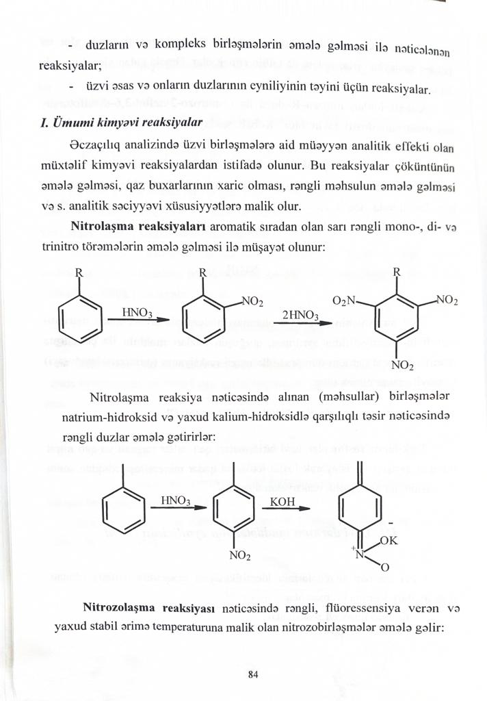
When the products obtained are reacted with sodium hydroxide or potassium hydroxide, colored salts are formed.
The reaction of the formation of nitroso compounds. Phenols form colorless, blue-green and blue-violet nitroso compounds.
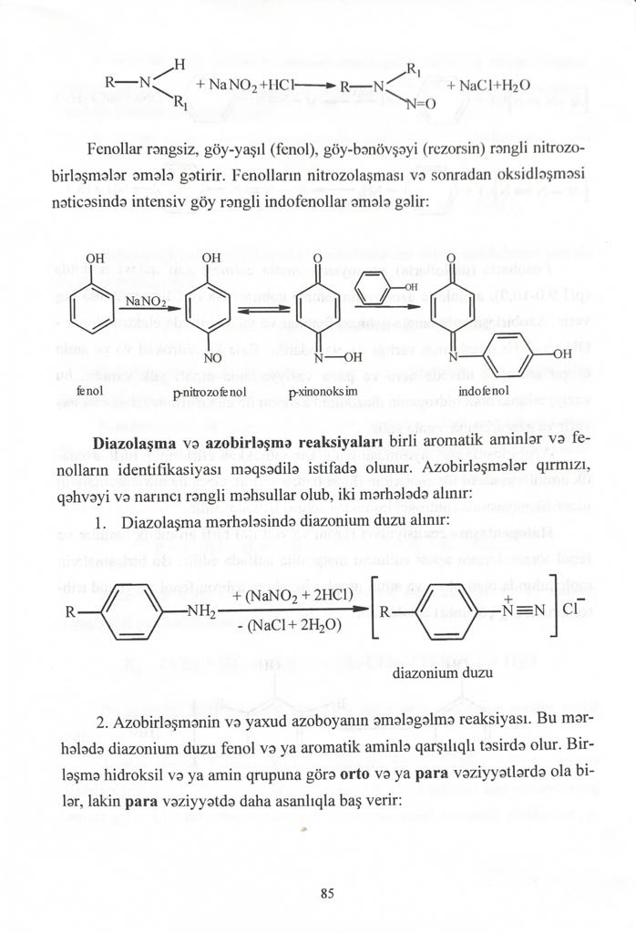
Indophenol
The reaction of dtazotization and the formation of azo derivatives (azo dyes). These reactions are used to open phenolic compounds containing primary amino groups. Diazotized amine combines with beta-naphthol to give a characteristic red or orange color.
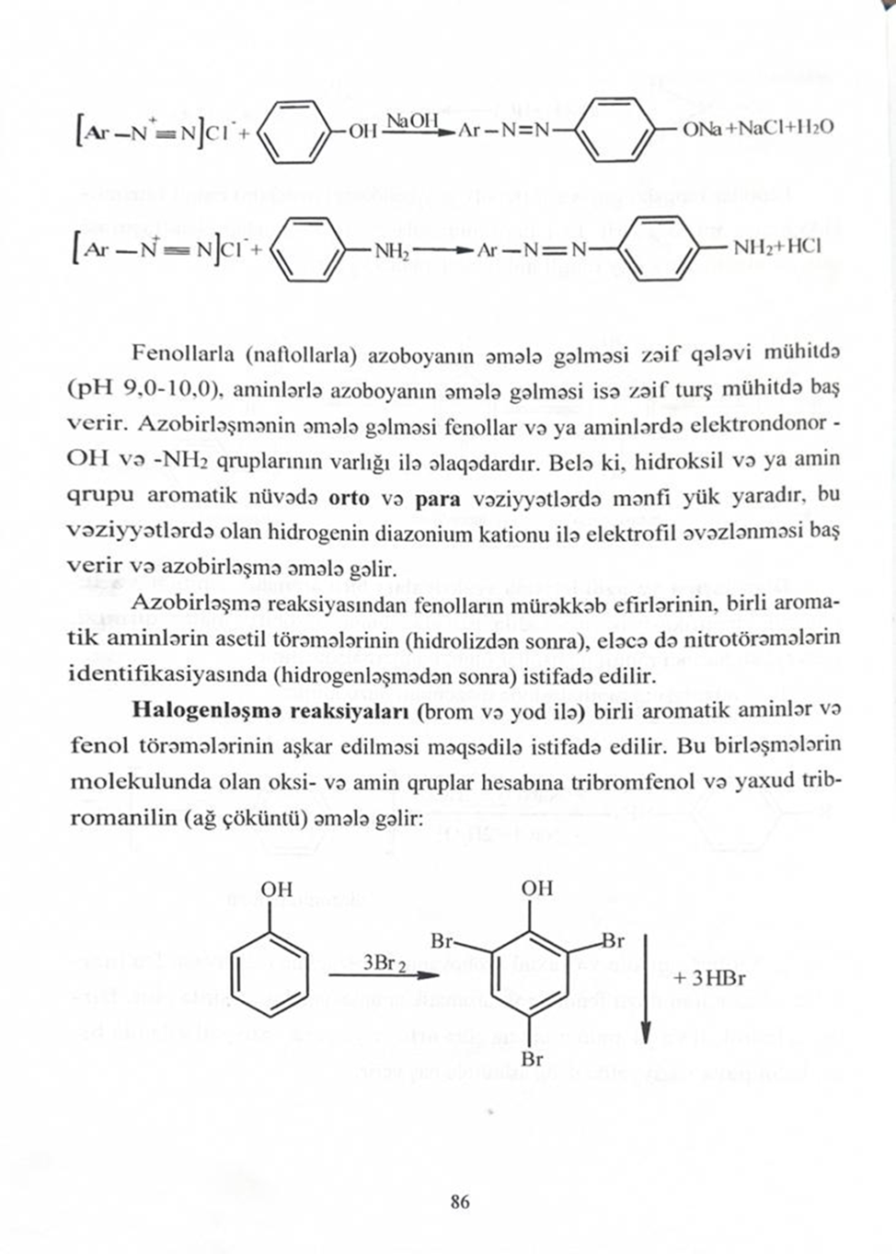
azo derivative

Phenolic compounds react with iron(3) chloride and form blue-violet substances.
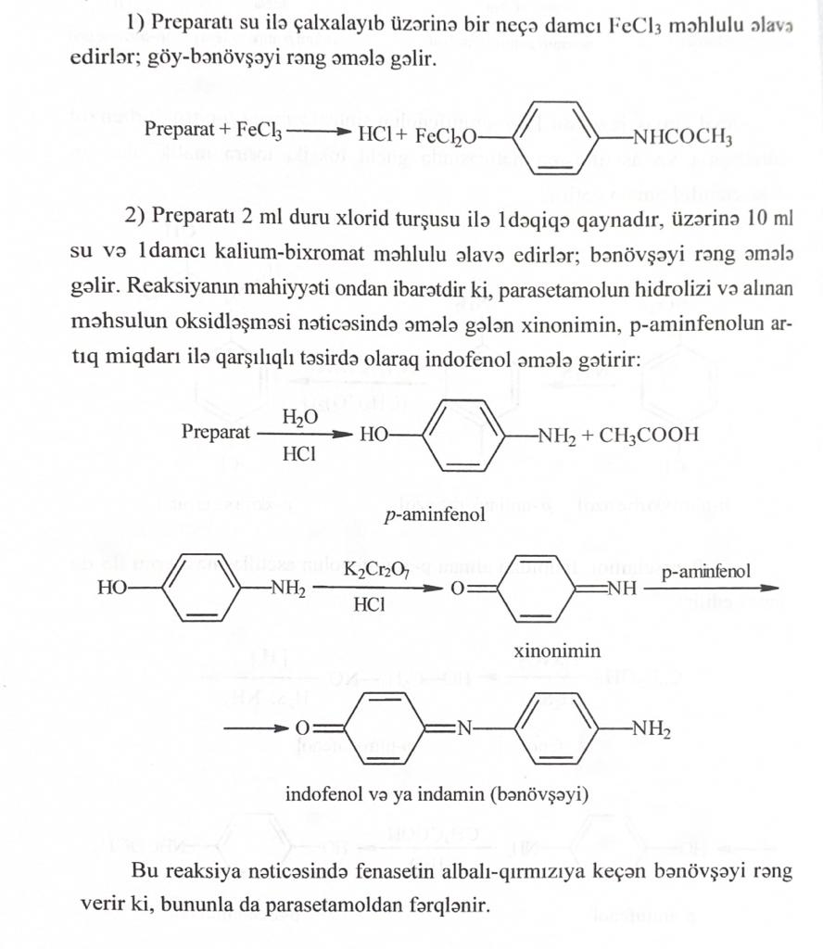
The reaction of the formation of indophenol dye. It is based on the oxidation of phenols to quinones, which, when condensed with ammonia or an amino derivative and an excess of phenol, form a purple indophenol dye. Under the action of sodium nitrite in an acidic medium, p-nitrosophenol is formed, which isomerizes to p-quinoidoxime, which, reacting with an excess of phenol in an acidic medium, forms indophenol:

Halogenation reaction. Used to open aliphatic double bonds - when bromine water is added, bromine is added to the double bond and the solution becomes colorless. A characteristic reaction of aniline and phenol is that when they are treated with bromine water, a tribromo derivative is formed, which precipitates.
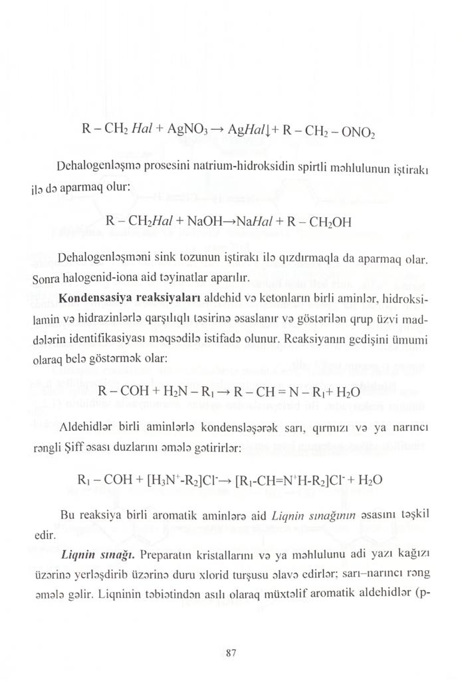
The dehalogenation process must be carried out in the presence of an alcoholic solution of sodium hydroxide.
Dehalogenation can also be carried out using zinc dust. Then a halogen test is carried out.
Condensation reactions.
Condensation reactions of carbonyl compounds. The reaction consists in the condensation of aldehydes and ketones with primary amines, hydroxylamine, hydrazines and semicarbazide:
Aldehydes condense with primary amines to form yellow, red or orange Schiff bases.
The resulting azomethines (or Schiff bases) have a characteristic yellow color. The reaction is used to identify, for example, sulfonamides. The aldehyde used is 4-dimethylaminobenzaldehyde.
Lignin test. When dilute hydrochloric acid is added to the preparation, a yellow-orange compound is formed. Lignin is tested with various aromatic aldehydes (p-hydroxybenzaldehyde, lilac aldehyde, vanillin, coniferyl aldehyde).
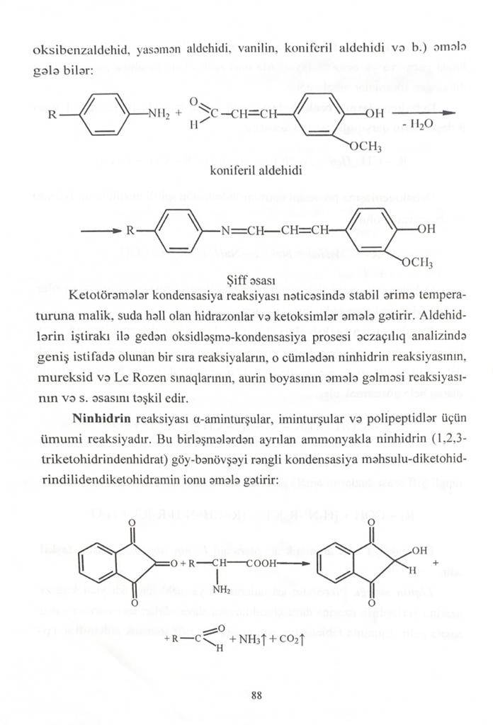
Coniferylaldehyde
Schiff base
ninhydrin reaction.
The process of oxidative cleavage and the formation of azomethine dye underlies the ninhydrin reaction. This reaction is widely used for the discovery and photocolorimetric determination of α- and β-amino acids, in the presence of which an intense dark blue color appears. It is due to the formation of a substituted salt of diketohydrindylidene diketohydramine, a condensation product of excess ninhydrin and reduced ninhydrin with ammonia released during the oxidation of the test amino acid:
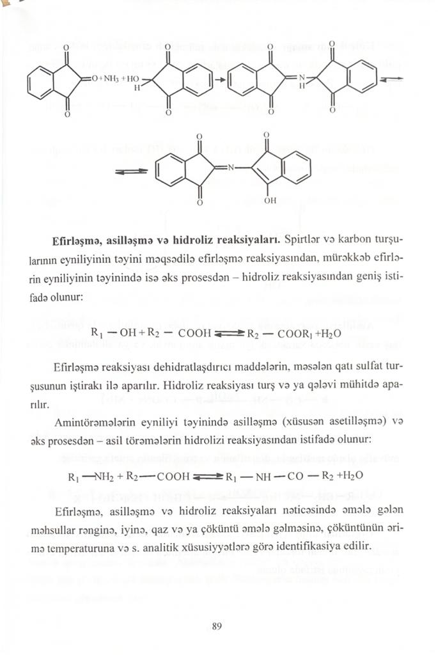
Hydroxamic reaction
The reaction is common for compounds containing ester, lactone, lactam, amide and imide groups. When interacting with hydroxylamine in an alkaline medium, hydroxamic acids are formed.
Which, after acidification with hydrochloric acid, form colored hydroxamates with salts of iron (III) or copper (II).
Methodology. 0.1 g of novocaine is dissolved in 2 ml of water, 2 ml of an alkaline solution of hydroxylamine is added, shaken for 5 minutes, 2 ml of diluted hydrochloric acid and 0.5 ml of a 10% solution of iron (III) chloride are added. Cherry color appears.
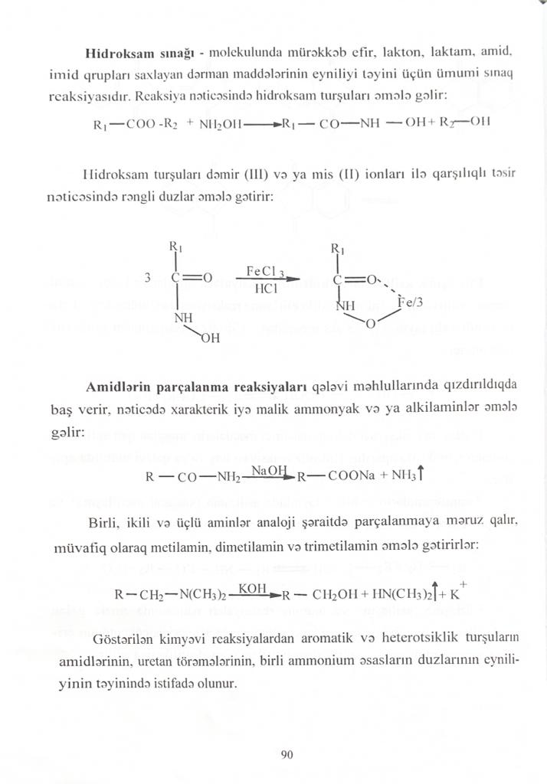
The decomposition reaction of amides occurs when heated in alkali solutions. In this case, ammonia is released or alkylamines are formed.
Primary, secondary, and tertiary amines decompose under similar conditions to form methylamine, dimethylamine, and trimethylamine.
The reaction of esterification, acylation and hydrolysis.
The esterification reaction is used to identify alcohols and carboxylic acids, and the hydrolysis process is used to identify esters (both in acidic and alkaline media).
To identify amino derivatives, the reaction of acylation (especially acetylation) and hydrolysis of acyl derivatives is used.
Substances containing a ureide group (acyclic and cyclic ureides, derivatives of guanidine and semicarbazone) release ammonia during hydrolysis.
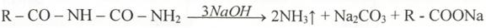
In pharmaceutical analysis, the pyrolysis reaction (thermal decomposition in a dry test tube) is widely used. The pyrolysis reaction is used to analyze sulfonamides, benzodiazepines and pyridine derivatives. During pyrolysis, alloys of different colors are obtained or various gases are released.
When bromisoval (an open-chain ureide drug) is boiled with an alkaline solution, the smell of NH₃ is noticeable.
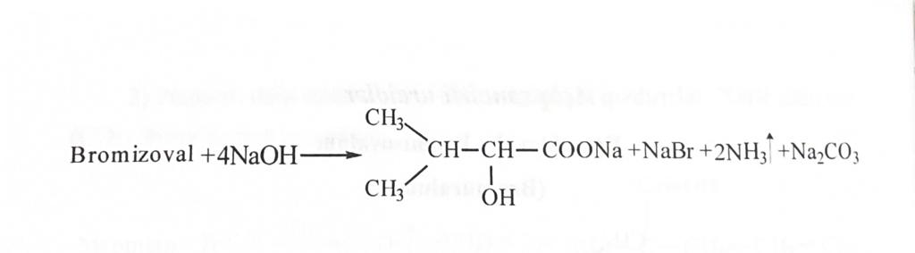
Preparations of aliphatic amino acids used in medicine - glutamic acid, aminocaproic acid, methionine, cysteine, acetylcysteine, penicillamine, etc. are preparations with nitrogen-containing functional groups. When determining the identity of these drugs when heated in alkaline solutions, the cleavage reaction of amides occurs. When alkali and triketonhydrin hydrate are added to a solution of penicillinamine, an intense blue or violet-blue color is obtained.
Another reaction to identify them is the ninhydrin reaction, which we can see in the example of glutamic acid.
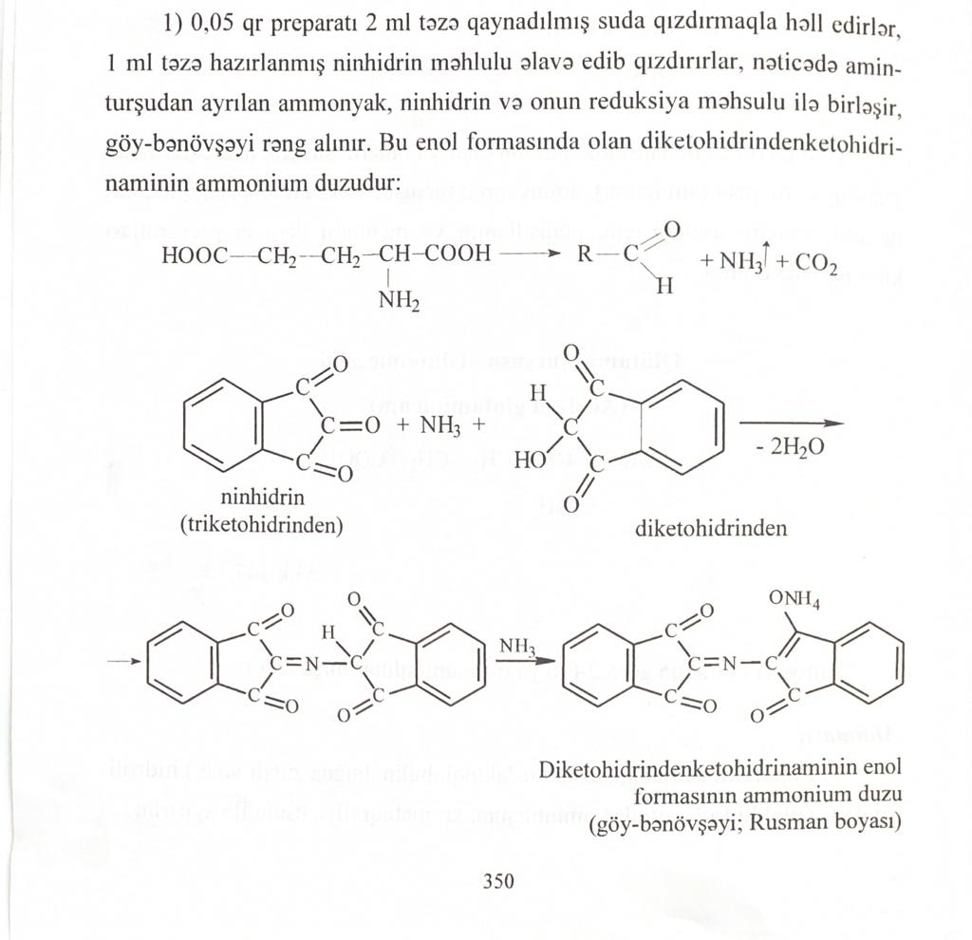
ninhydrin diketohydrinden
Roussman's dye

Bromhexine hydrochloride and ambroxol hydrochloride, belonging to the bromarylamine group, react with an azo dye due to the presence of one aromatic amino group in the molecule.
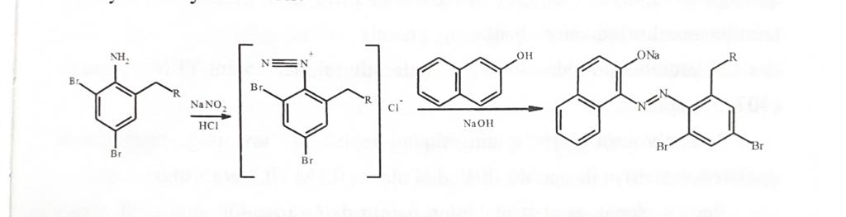
Paracetamol, a derivative of para-aminophenol, reacts characteristically with indophenol (2), azo dye (3-4) and 3-iron chloride (1).
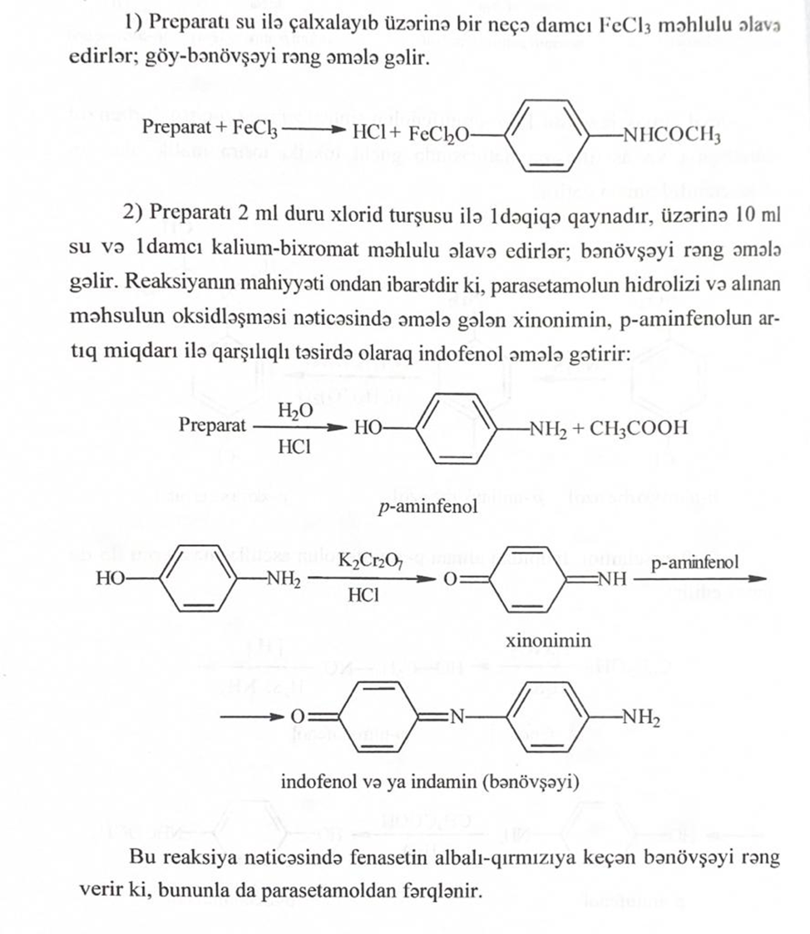
3. The drug forms diazonium salts on the phenolic hydroxyl, and then an azo derivative.
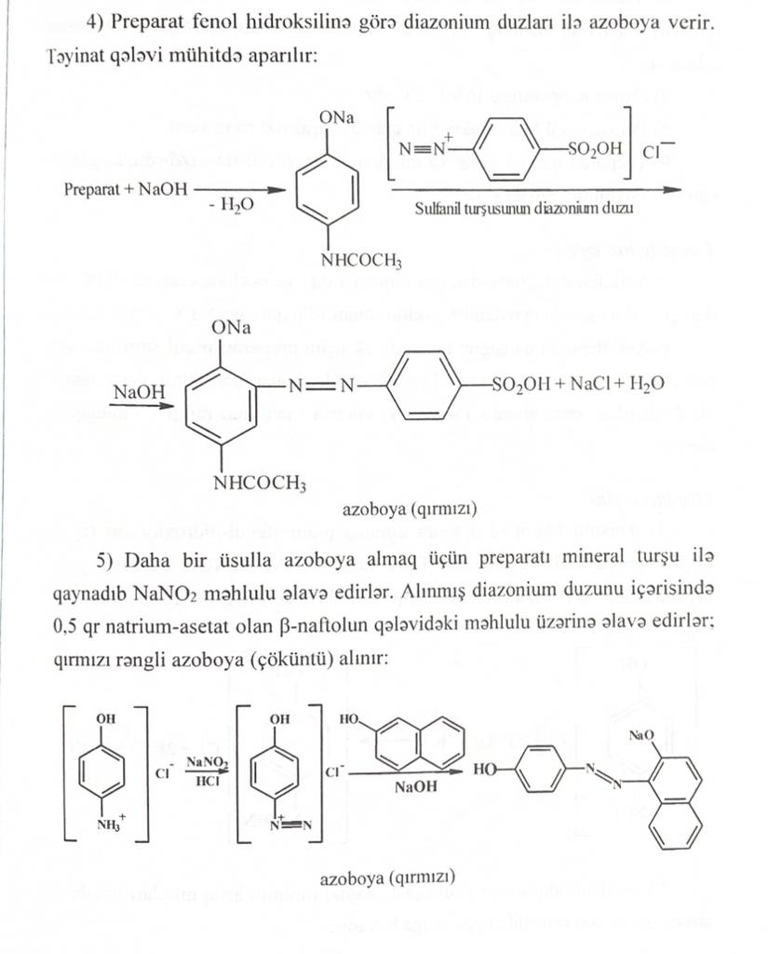
4. According to the primary amino group, a diazonium salt is obtained (by exposure to sodium nitrite), and then an azo derivative is obtained by acting with a solution of beta-naphthol in sodium acetate.
Salicylamide and oxaphenamide, which are derivatives of salicylic acid amide, cause reactions with iron (3) chloride (1), cleavage of amides (2), halogenation reactions (3) and indophenol (4).

1.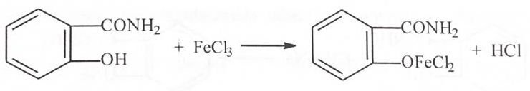

2. 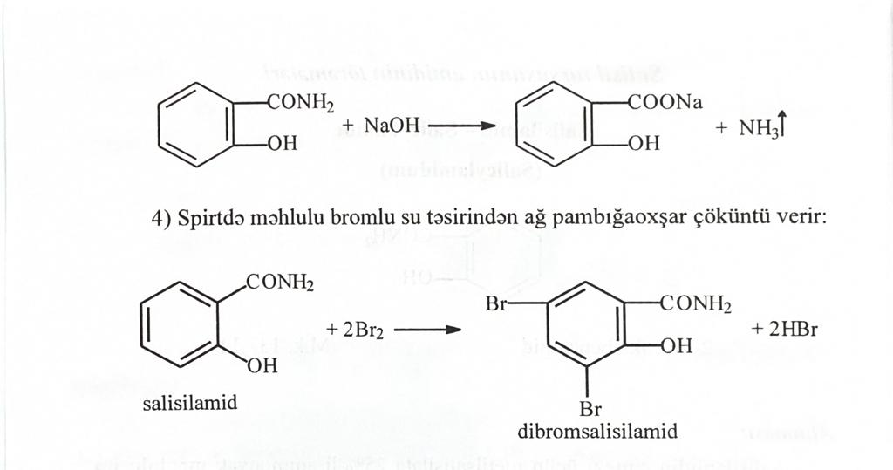
3.
4.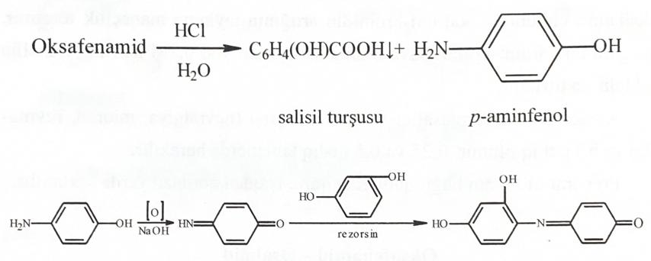
To determine the derivatives of para-aminovenols (benzocaine, procaine, procainamide, dicaine), a lignin test (1), azo coupling (2), hydrolysis (3), isonitrile formation (4), Vitali-Morena (5) are used.
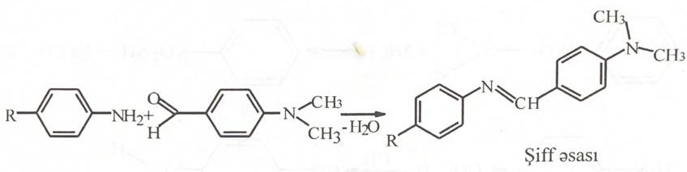
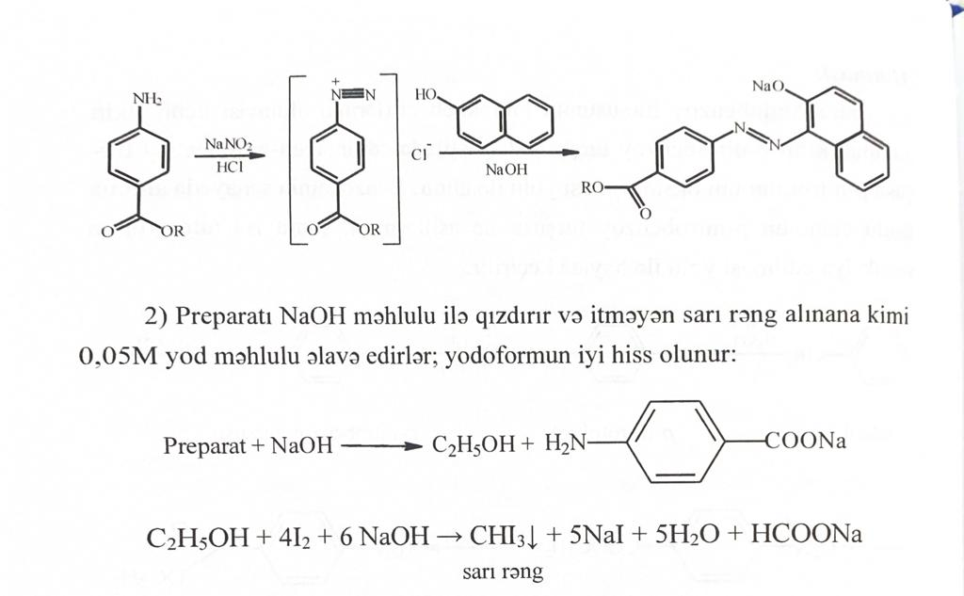
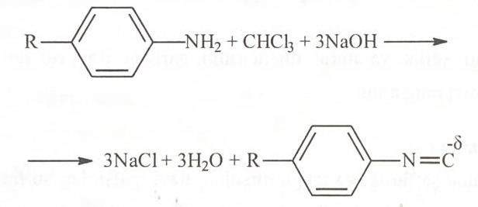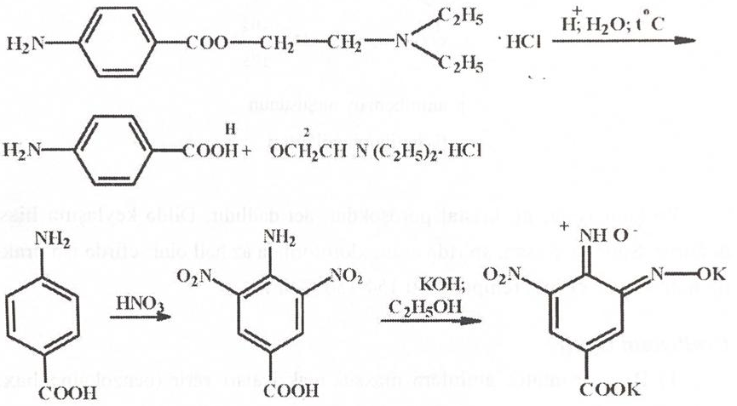
The drug Metoclopramide, which belongs to the amides of para-aminobenzoic acid, also reacts to form an azo derivative.
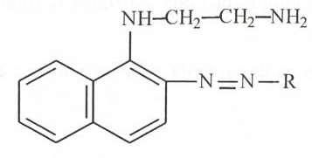
Preparations Na-para-aminosalicylate and Bepask, related to derivatives of para-aminosalicylic acid, react with iron (3) chloride (1), 2,4-dinitrochlorobenzene (2), forming an azo dye (3) and Schiff base (4).

1.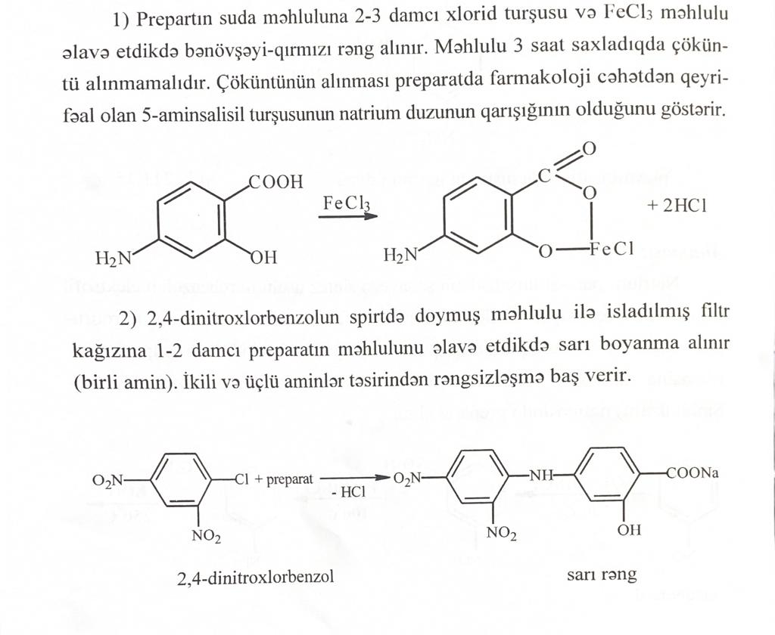
2.
3.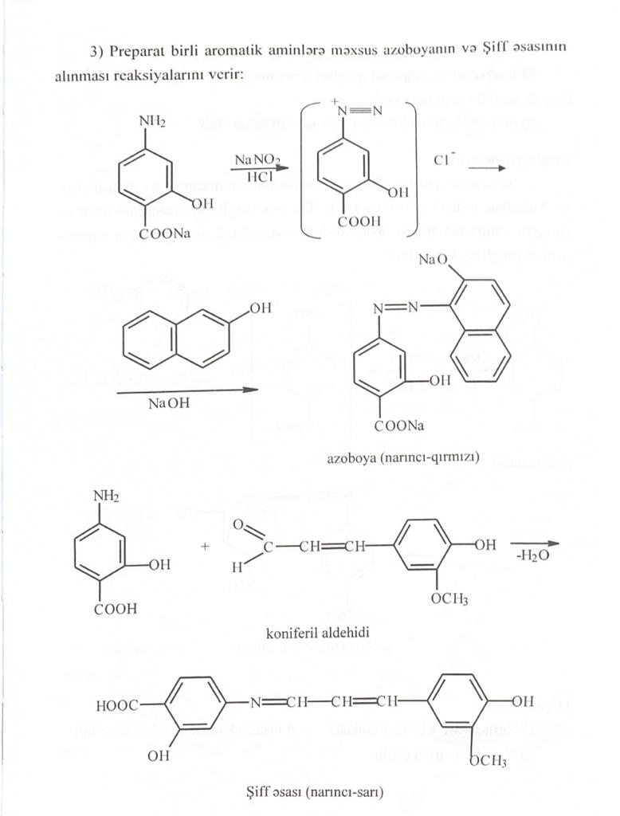
The representative of catecholamines Adrenaline hydrochloride is identified by the reaction of cleavage of amides (1), the formation of ortho-quinones (2), the nitration reaction (3), the reaction with iron (3) chloride (4).

1.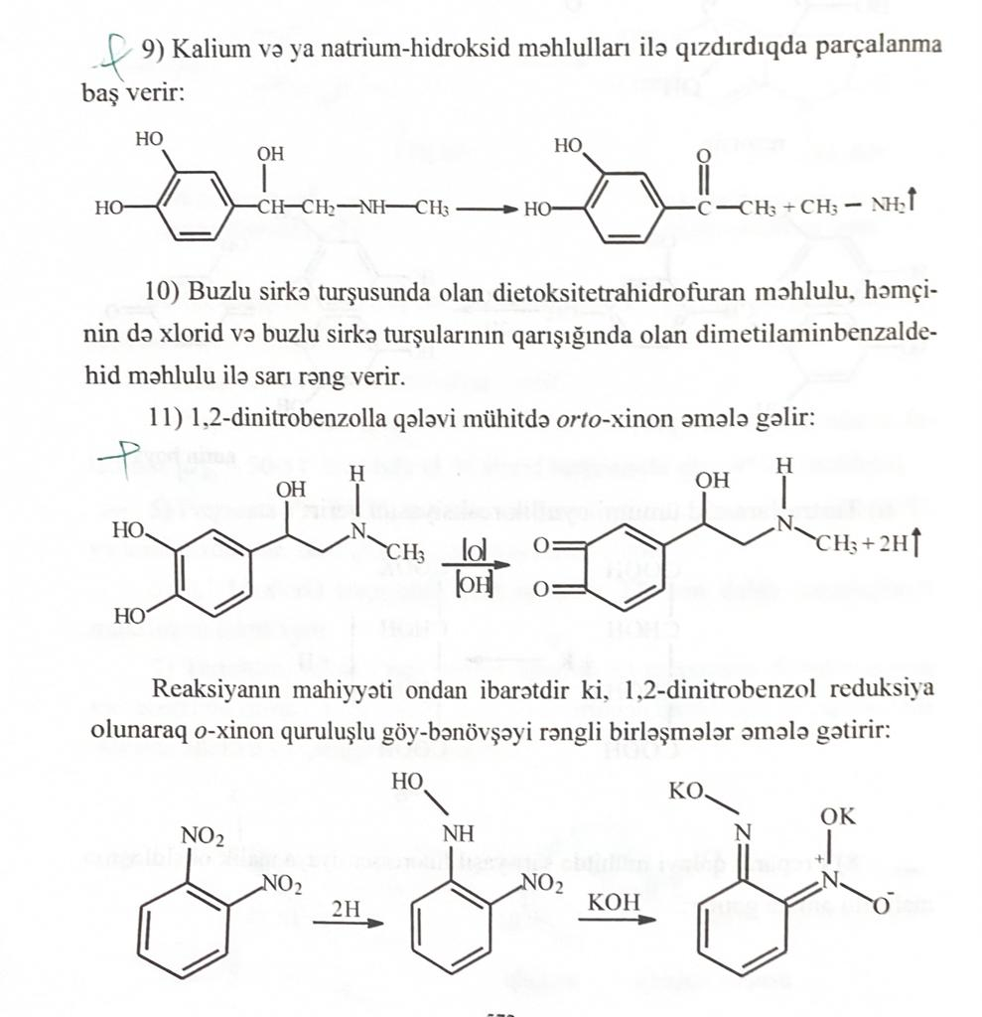
2.
3.
4.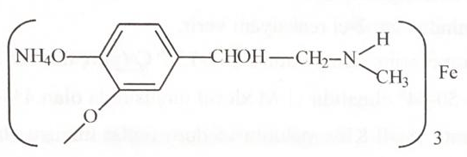
To determine the derivatives of nitrophenylalkylamines (chloramphenicol (levomycetin)) alkaline hydrolysis (1), azo coupling reaction (2) is used after the reduction of the nitro group to the amino group.

1.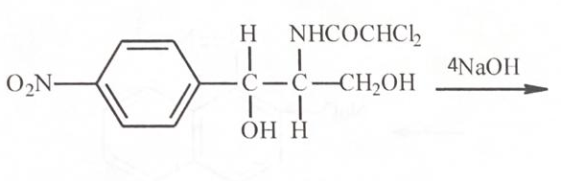
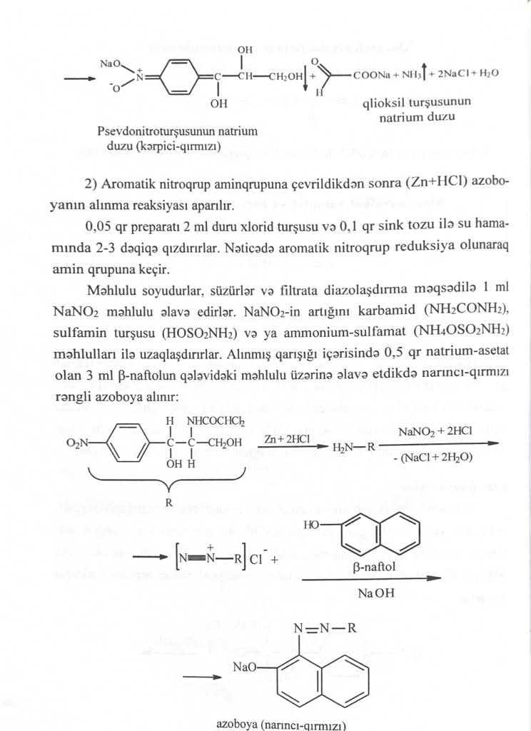
2.
To identify sulfanilamide preparations (streptocide, sulfacyl-Na, sulfadimezin, sulfadimethoxine, urosulfan, sulfasalazine, etc.), a condensation reaction with 2,4-dinitrochlorobenzene (1) and lilac aldehyde (2), a lignin test and obtaining a Schiff base (3) are used , condensation, azo dye formation (4), halogenation reactions (5).

- 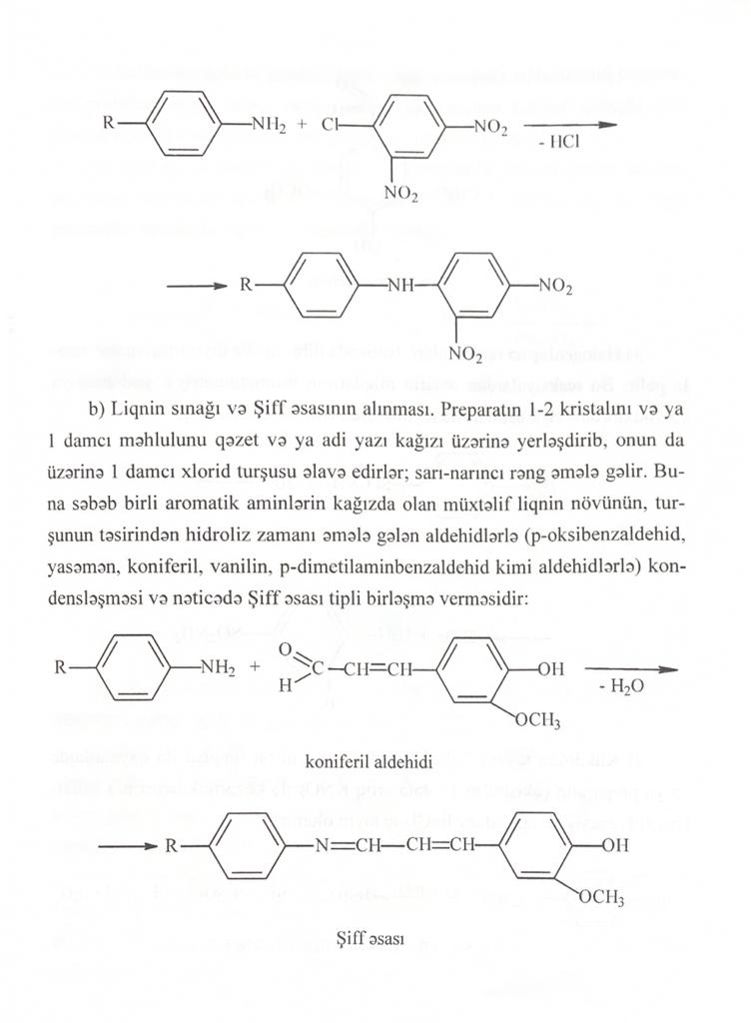
- 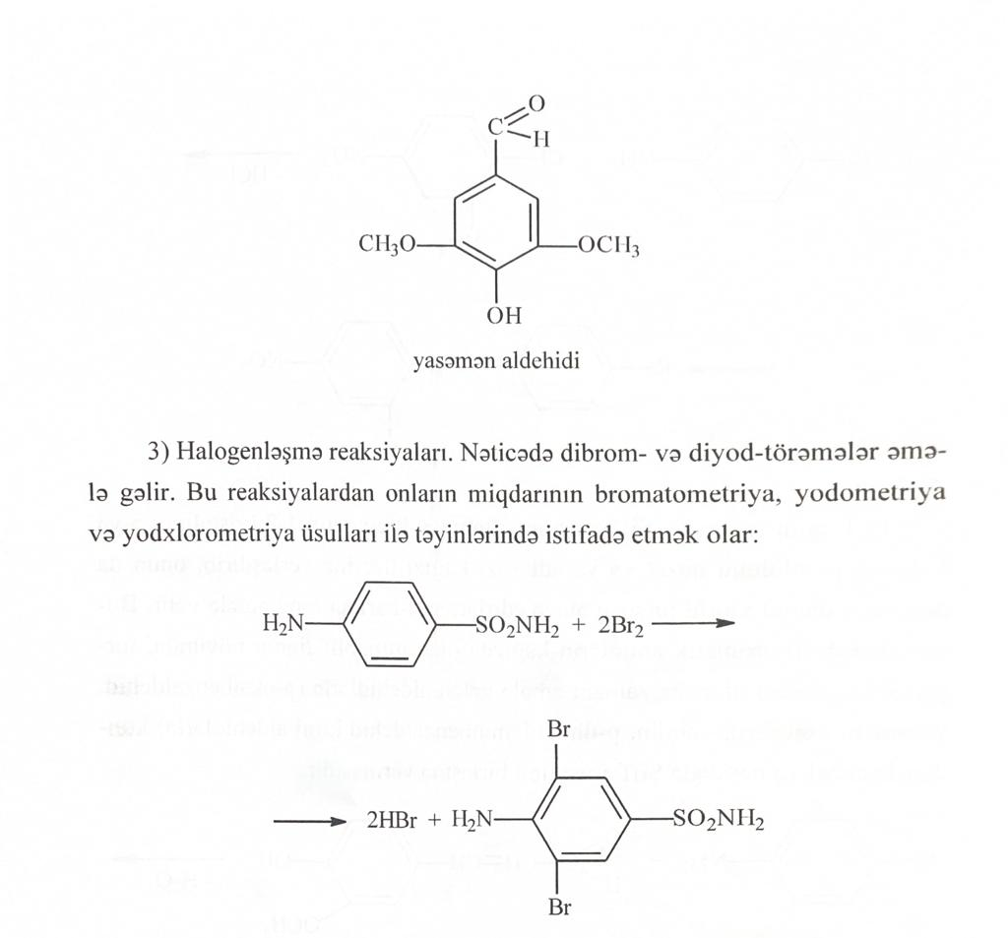
3.
4.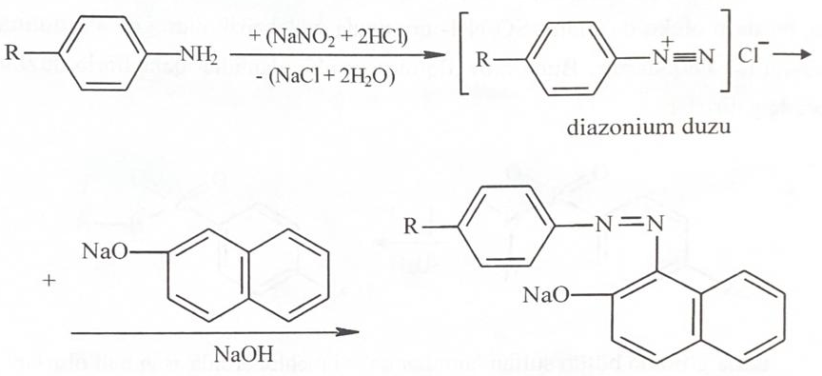

5.
Furosemide, which is a derivative of chlorobenzenesulfonic acid amide, undergoes a hydrolysis reaction (1), an amide cleavage reaction, and an azo dye reaction (2).

1.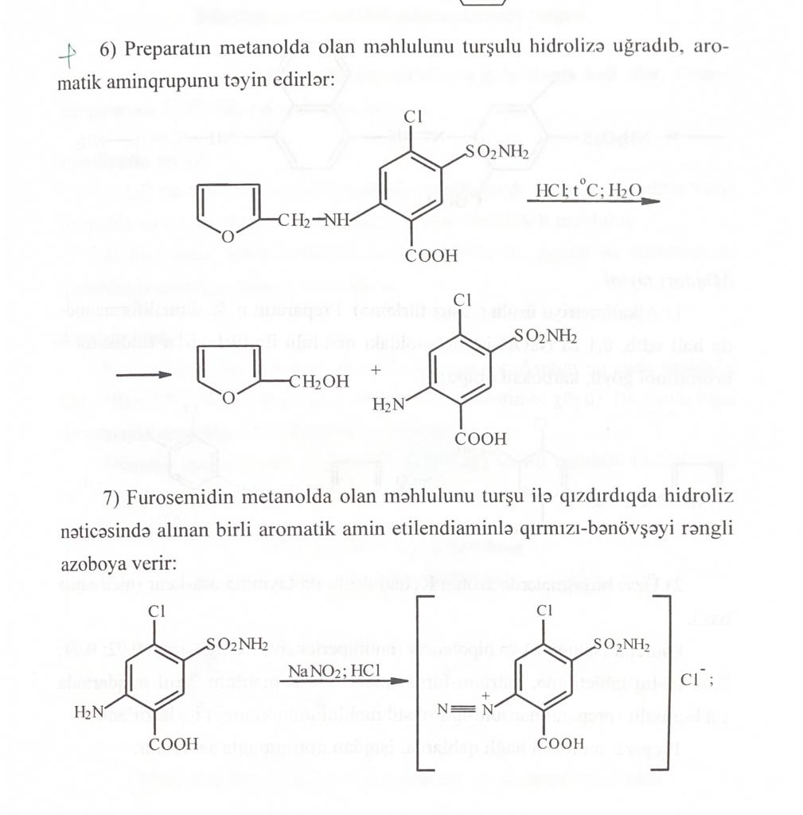
2.

